A Fateful or Faithful Attack?
Mitchell Lurie
Woodwind World, September 1959
Used by permission.
This was the sixth night in a row for the Beethoven Fifth Symphony, and as we turned into the fourth movement of this so-called "fate" symphony, it was to be another horrible fate for me. I was playing first clarinet in the Stokowski All-American Orchestra, on a tour of the U.S. and Canada. The torture? Simply playing eight consecutive A notes in the solo phrase:
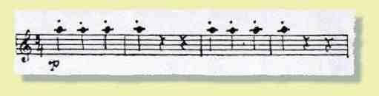
You ask, "Why torture?" Please notice the dynamic marking. This seemed to keep me from playing the solo surely and cleanly. At the conclusion of this sixth fiasco, I decided that there must be a way to attack notes surely and cleanly in any dynamic range -- particularly pianissimo.
This is a problem that can rob us of peace of mind, and true enjoyment in our work. In finding out a set of fundamentals that worked to solve this elusive problem, I have studied the ways of attack and articulation as taught in the various schools of clarinet, and in the following paragraphs I shall present the principles that have worked both for me and my students.
Let us consider that you have a good reed, chosen for qualities of tone and response that satisfy you. We shall assume the reed is working properly (easier said than done) and say no more about it. The preparations for attack comprise three steps:
- The corners of the embouchure are pulled back as in a smile.
- The center of the embouchure is firm, without pinching or biting.
- The diaphragm supports the wind at all times.
Now to take the steps one by one:
The corners of the embouchure, when drawn back into smiling position, give the most support to tone production without any detrimental effects. When the corners are drawn back too far, air escapes from the sides, and this can be quickly detected and corrected. I have heard and read more words dedicated to the "pointing of the chin" than anything else in the discussions of clarinet embouchure, and I want to go on record as firmly opposing this approach. Mind you, I am not quarreling with the pointing of the chin in itself, but rather the use of it in establishing embouchure position.
I maintain that if the corners of the mouth are brought back properly, the embouchure takes on a flat, pulled-back aspect. In this way, the muscles of the face and chin will naturally follow in this flat conformation. Remember, each of us has a different facial structure, with different muscular developments, for which individual variation allowances must be made. When the pointed chin is stressed, the rest of the embouchure is not necessarily brought into position, and more often than not, strain and pinching is the result. A sad illustration of this preoccupation with the pointing chin is the case of several young players who came back from contests with very confusing results. In each case, the judges had given an A- plus in the tone department, remarking, "Beautiful tone," etc., and then giving a bad mark in embouchure for the lack of a pointed chin. I leave it to you to figure this out.
The second step is perhaps the most critical point I wish to discuss. This concerns the pressures in the center of the embouchure. It is here that tone quality, attack, and slurring large intervals (just to mention a few points), will be achieved or lost. I am referring to lateral or biting pressure. A few moments of experimenting will show how disastrous too much biting pressure in the center is to pianissimo attack. Remember, you cannot bite down in the corners of the mouth, so what I am concerned with is the absolute center of the embouchure.
A good exercise is to start the tone, then try alternately loosening and biting in the center, holding the tone throughout. Your ear will be the judge of which is the correct amount of pressure to use. A most critical time for the center pressure arrives shortly after the opening of Richard Strauss' "Death and Transfiguration." Remember?
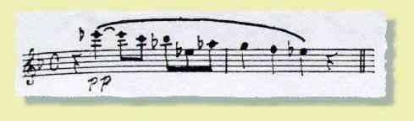
Maybe you can perform this solo passage well at home or in the rehearsal room, but how about concert night when the conductor's stick moves to the pianissimo entrance on the second beat? Well, so far, we have brought back the corners of the embouchure, and now we are desperately trying to keep from pinching in the center (performance nerves). At this point I bring in:
Step three -- diaphragm pressure, the all-important support of the wind. I hasten to mention that when I speak of diaphragm pressure, I mean it to be a steadily rising movement of the diaphragm muscle, pushing the wind ahead of it up to the clarinet. One common mistake I have noted is pushing the wind against a set diaphragm that does not move. While this will work, it is a strained way, and quite tiring.
Try this exercise: Place your hand on the diaphragm area, breathe in deeply (which should push your hand outwards) and blow a column of air through a small opening in your lips. If you are pushing your wind with the diaphragm muscles, your hand should depress steadily until you are out of wind. To encourage this, give a firm steady pressure with the hand to work the diaphragm properly. Then take up your instrument and see if you can achieve the same effect. When you support your wind in this manner, the instinctive pinch that we usually set up in the embouchure will be offset to a great extent. You will also find that the greater the pianissimo, the more diaphragm support is needed. Give it a try. If you have good wind support, you will be well on your way to control a deadly enemy of the clarinetist--the pinched embouchure.
One final reminder: More often than not, we are guilty of taking too little mouthpiece into the mouth. Experiment by sustaining a tone while taking more, and then less, mouthpiece. As in the similar experiment with center pressures, your ear will be the best judge.
One of my prime aims as a player and teacher is to develop the clarinetist who sees the elusive high G coming up in the trio of the Beethoven Symphony—
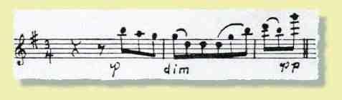
and enters the phrase with the constructive and positive thought:
- Corners back (for support of my embouchure).
- Center firm, but not pinched (so that Beethoven will be served).
- Diaphragm support (to control the wind and discourage pinching).
And at this point, the desired pianissimo attack will be a reality instead of a nightmare.

Mitchell Lurie is a graduate of the Curtis Institute of Music, where he studied under Daniel Bonade and Marcel Tabuteau. He has been solo clarinetist with the Pittsburgh and Chicago Symphony Orchestras and is now engaged in motion picture and television recording in Hollywood. He has made numerous chamber appearances with the Budapest, Paganini, Hollywood and Hungarian quartets. He teaches clarinet and heads the woodwind ensemble department at the University of Southern California. He is also on the faculty of the Music Academy of the West in Santa Barbara. Last spring he appeared at the Library of Congress in a first performance of the Reger quintet with the Budapest Quartet. Besides teaching and playing he heads ML Mouthpieces, which is engaged in the production of quality clarinet mouthpieces.
http://www.clarinet.org/Anthology1.asp?Anthology=8

